Présentation du Groupe de Travail (Fr) | Work Group Presentation (En) | Guide de transition (Fr) | Lettre Ouverte aux Editeurs de Logiciels  + Communiqué (Fr) | Open Letter to Software Vendors  + Press Release (En)

French-Speaking PostgreSQL Cross-Enterprise Work Group
The Cross-Enterprise Work Group ( called “Groupe de Travail Inter-Entreprises” - acronym PGGTIE - or “GT Inter-Entreprises” in French) is a dedidacted task force inside the PostgreSQLFr non-profit association.

NOTE : this page is a translation of the original page in French. Despite our effort to maintain this translation, it may not be up to date with the source.

Objectives
The objective of the group is to join our efforts for 3 concrete actions:
- Share feedback, good practices, studies (performance, migration, …).
- Contribute to the sustainability & improvement of PostgreSQL, in the spirit of Free and Open Source Software.
- Encourage the use and adoption, especially support of PostgreSQL by software editors.
This group is by nature “open” and enthusiastically welcomes good will, with nevertheless some requirements

Members
To date, the group has more then 20 members, including :
AGIRC-ARCCO, Air France, A-SIS, Carrefour, CASDEN, CIRIL-Group, CNES, Code-Lutin, EDF, ENEDIS, iMSA, IGN, ISOCEL (Leclerc), MAIF, Météo France, le Ministère de l’Éducation Nationale, Orange, PeopleDoc, SNCF, Société Générale or furthermore Tokheim Service Group
AGIRC-ARRCO | Air France | 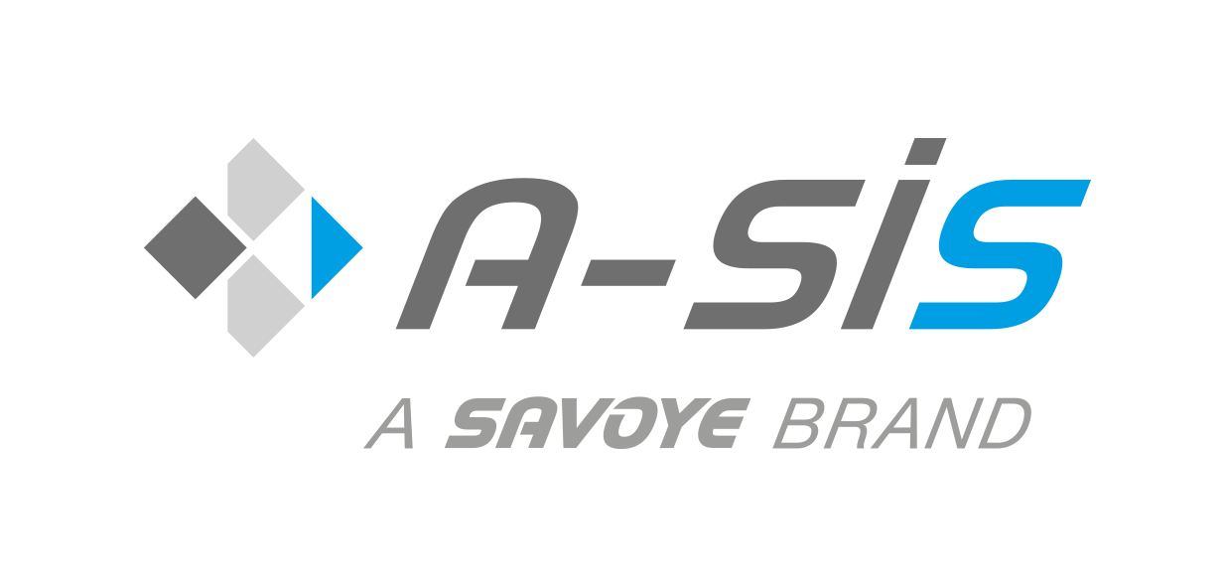A-SIS | 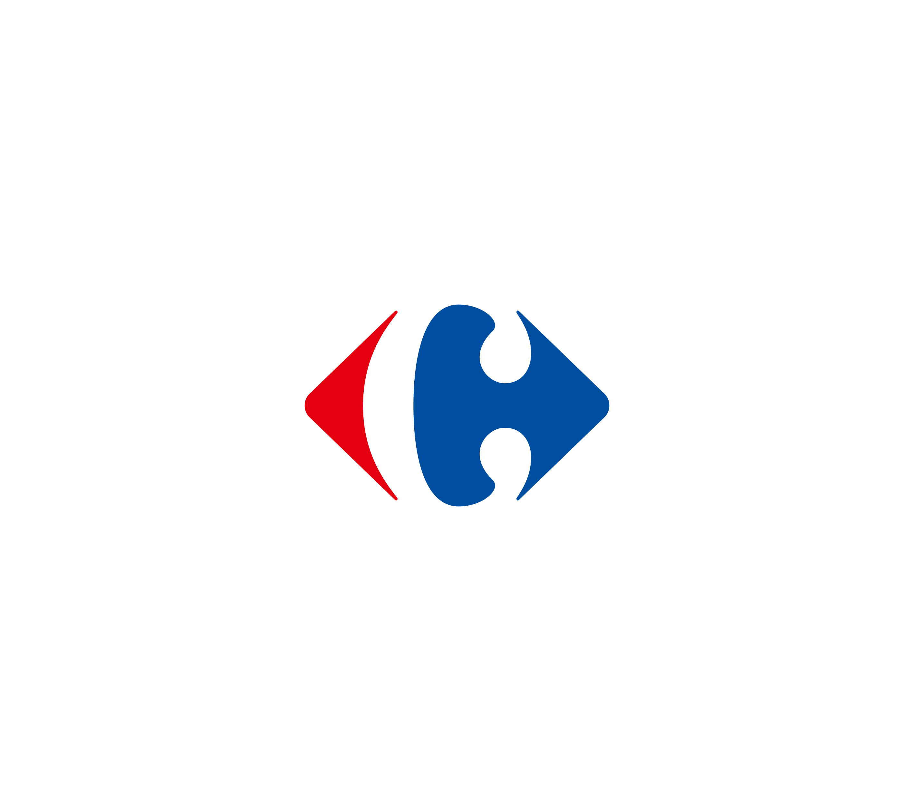Carrefour | 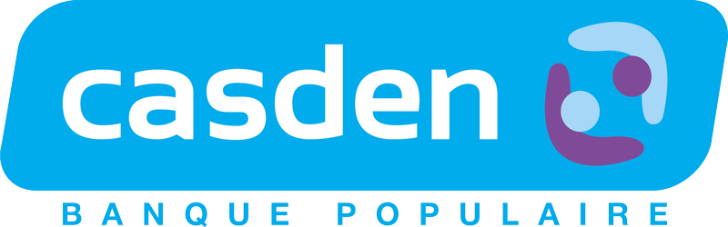CASDEN
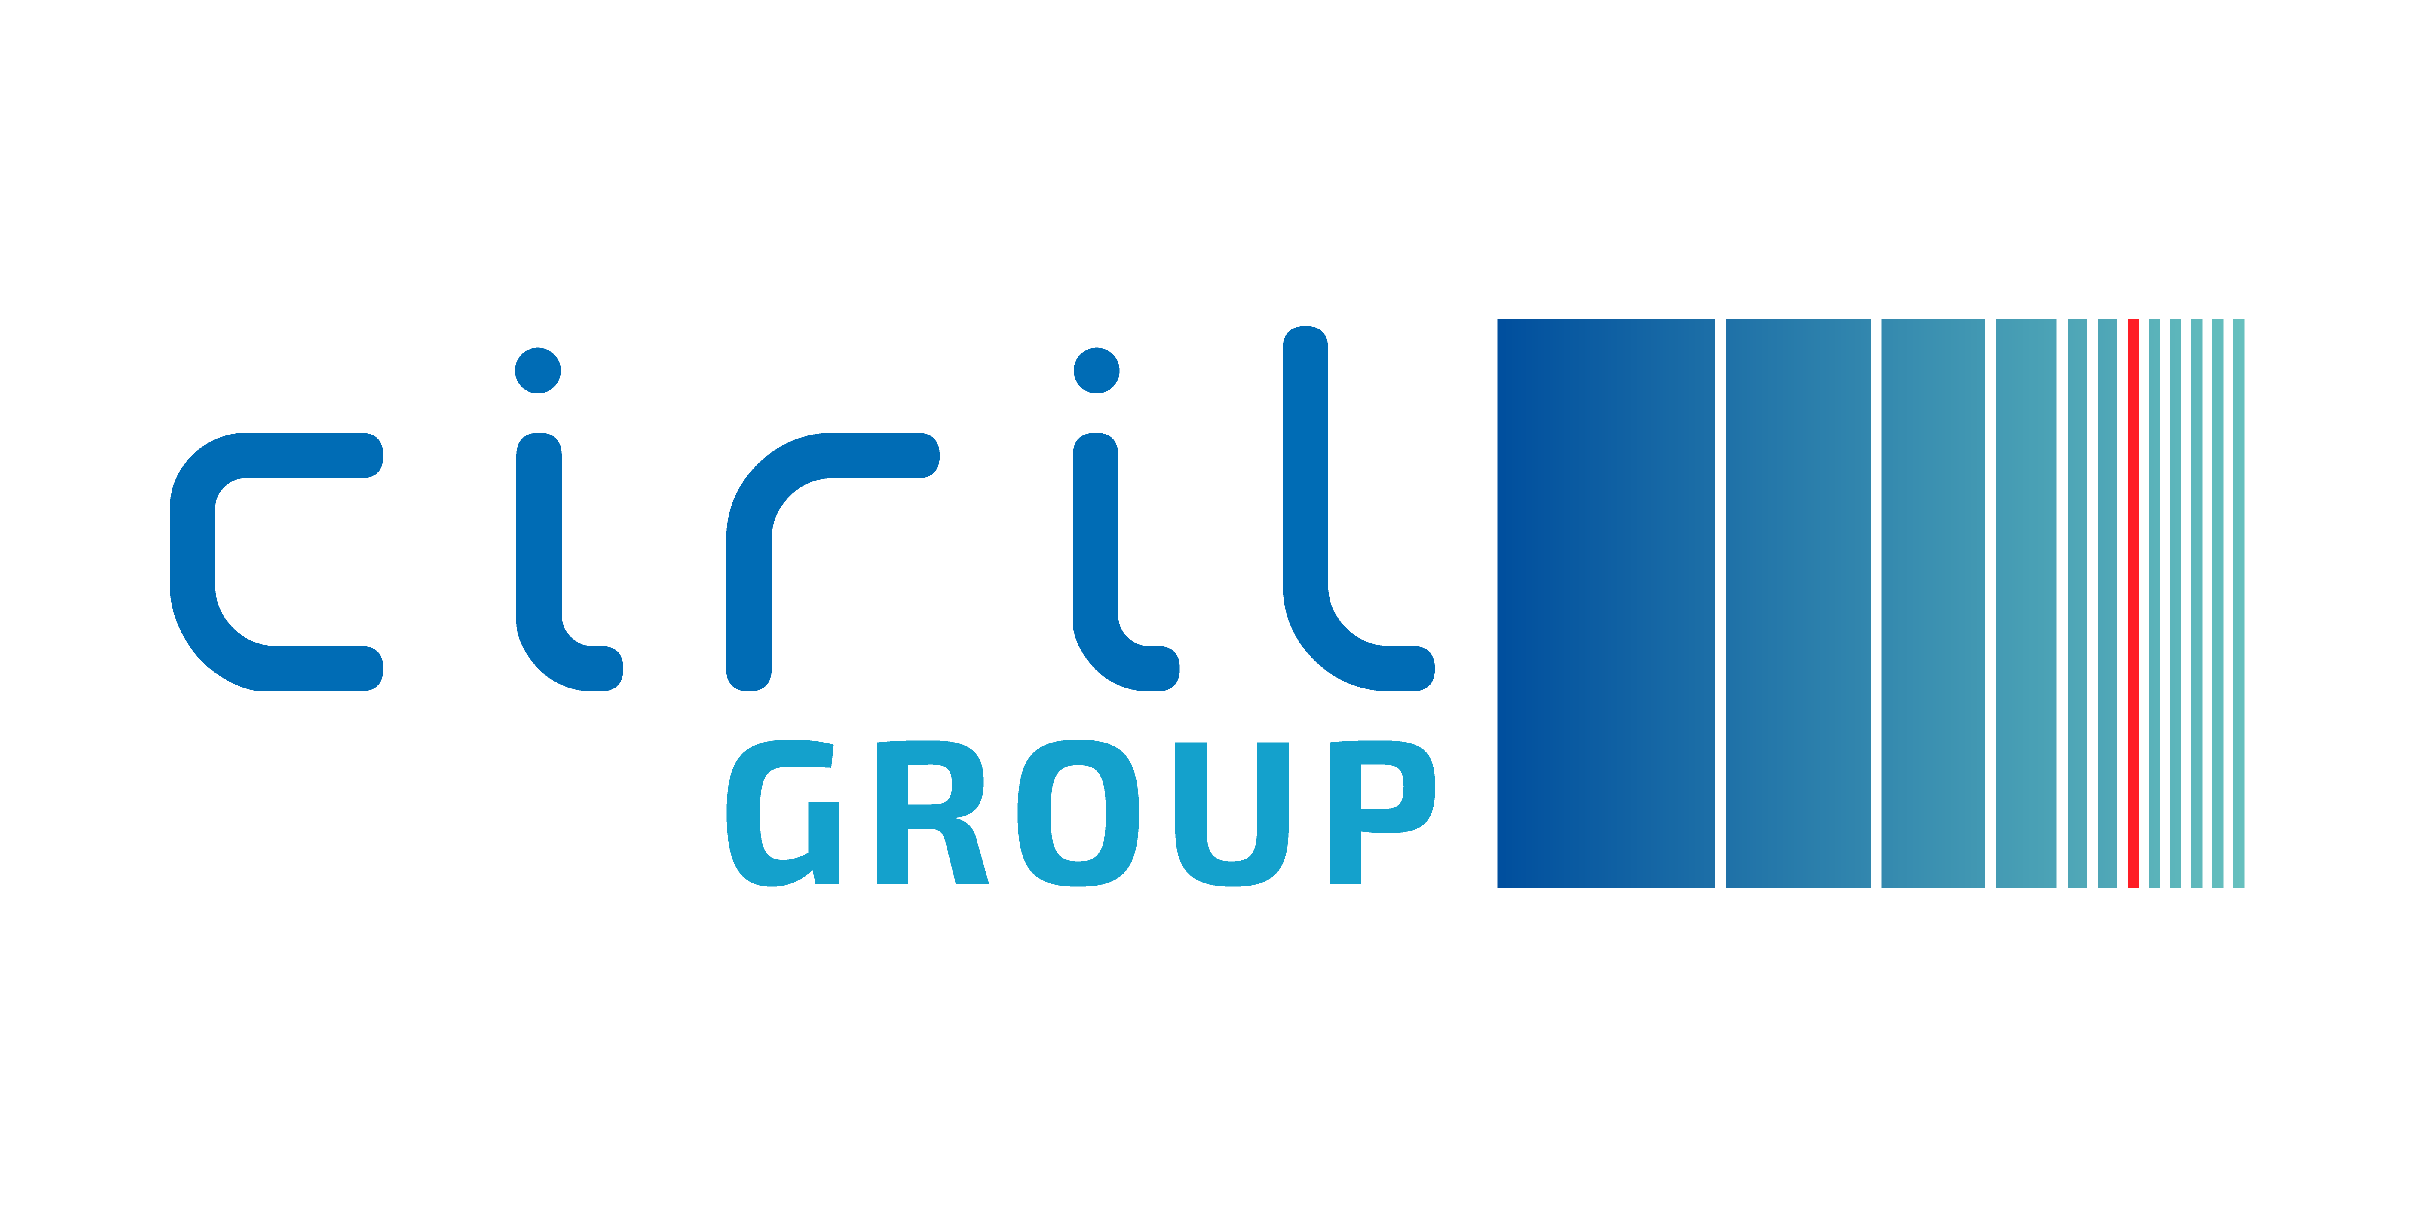CIRIL group | 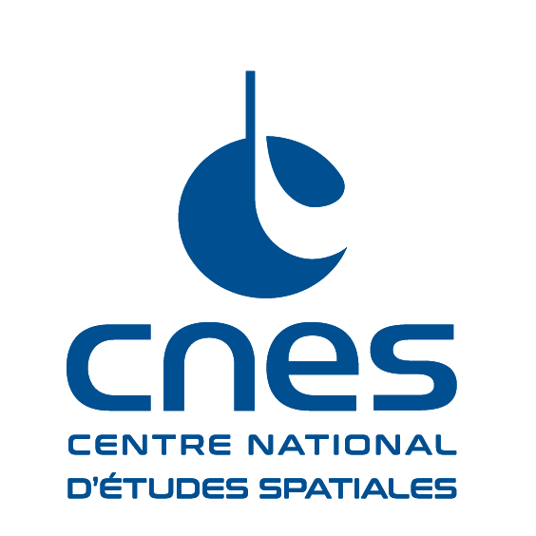CNES | 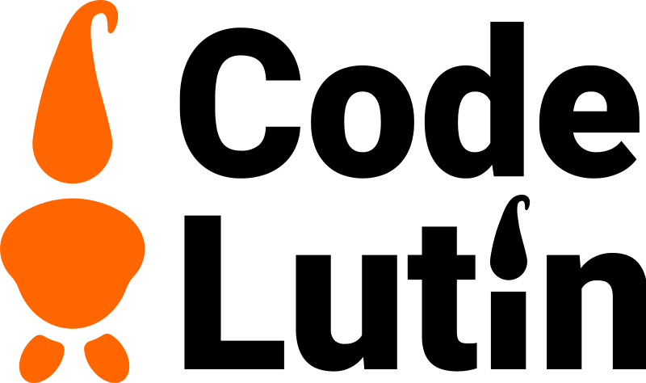Code Lutin | 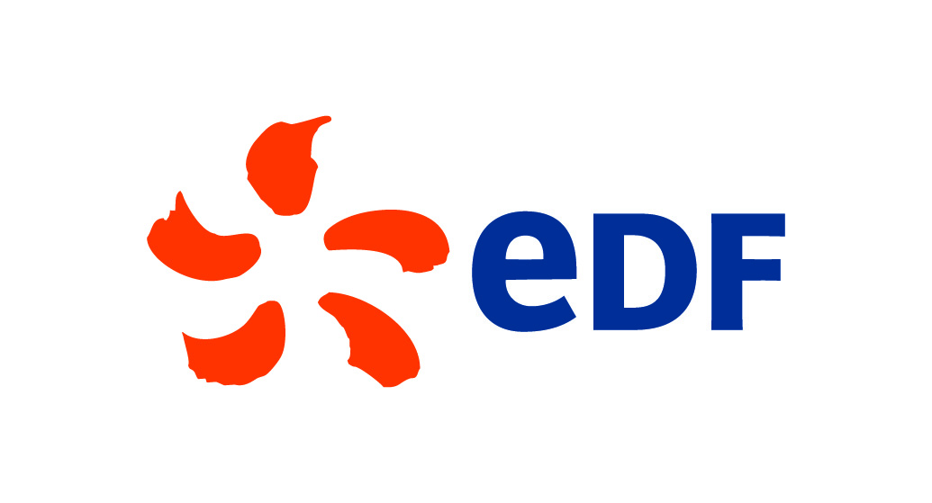EDF | ENEDIS
iMSA | 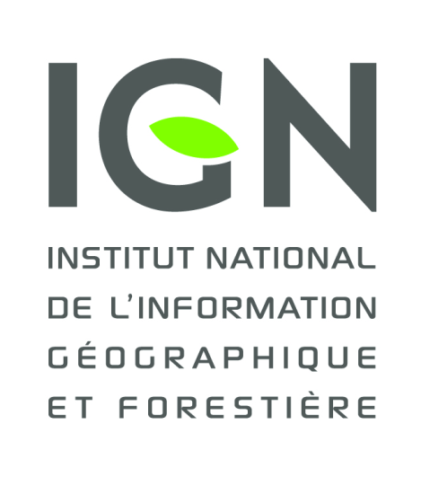IGN | 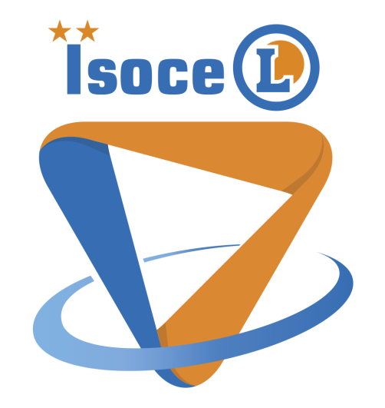ISOCEL (Leclerc) | 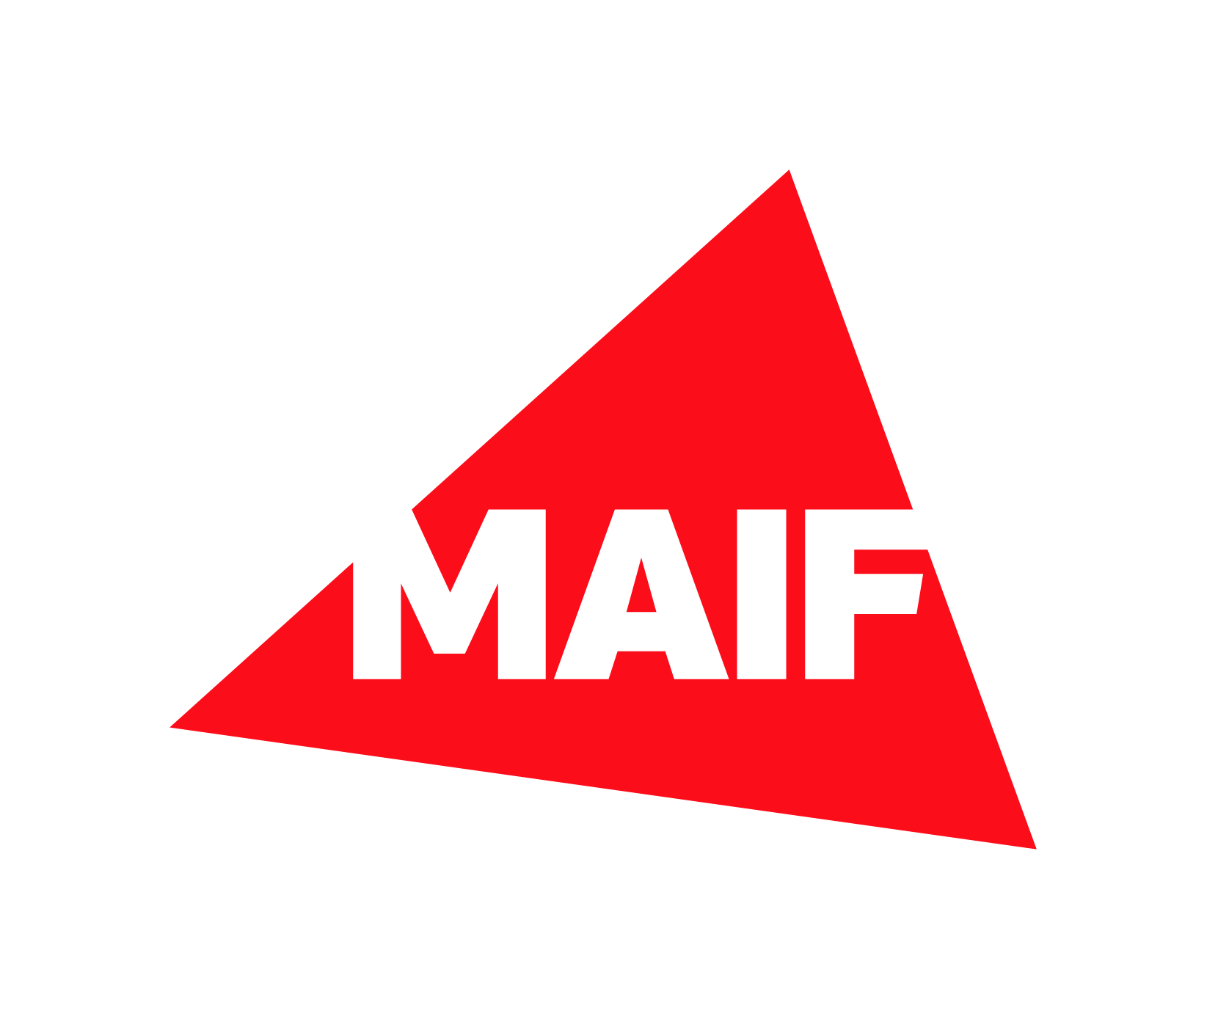MAIF | 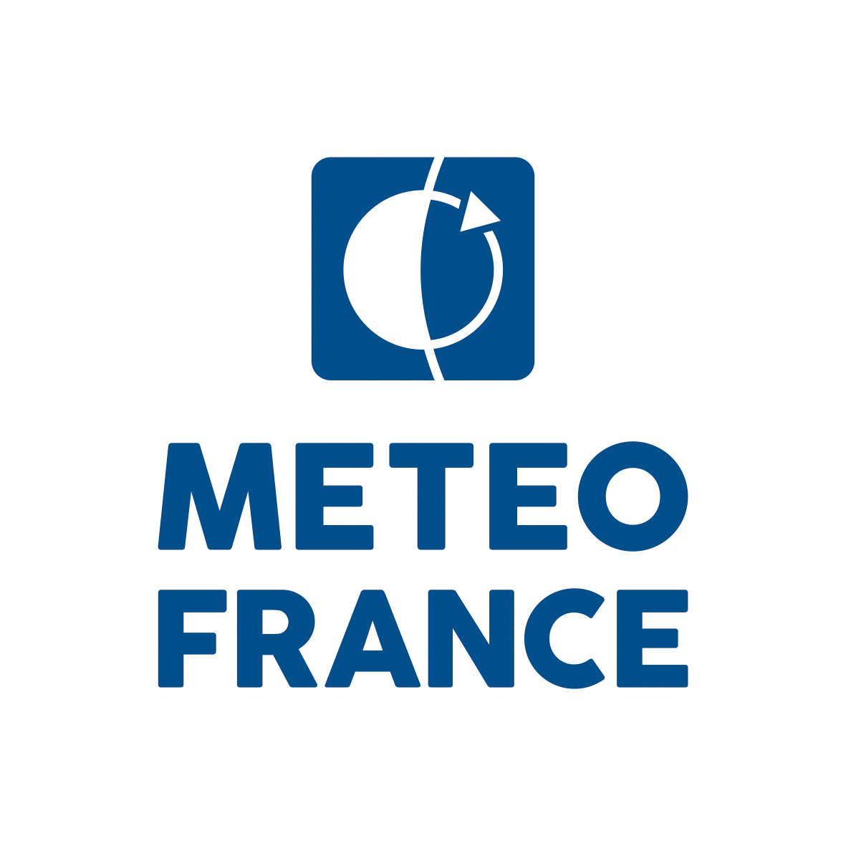Météo France
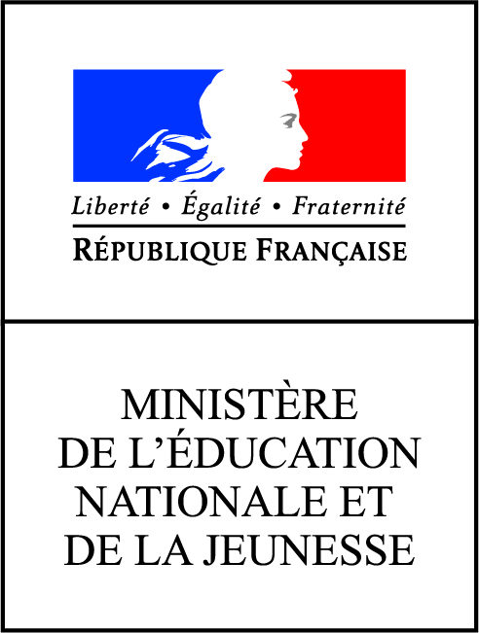Ministère de l'éducation nationale et de la jeunesse | 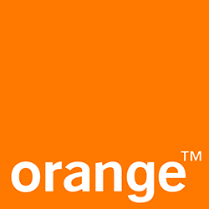Orange | 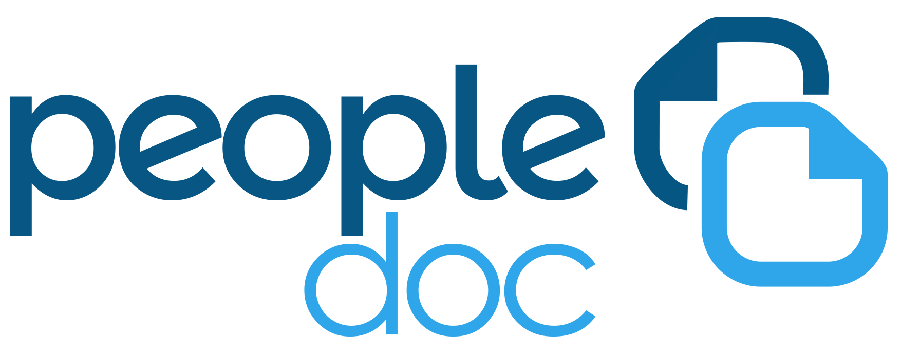PeopleDoc | 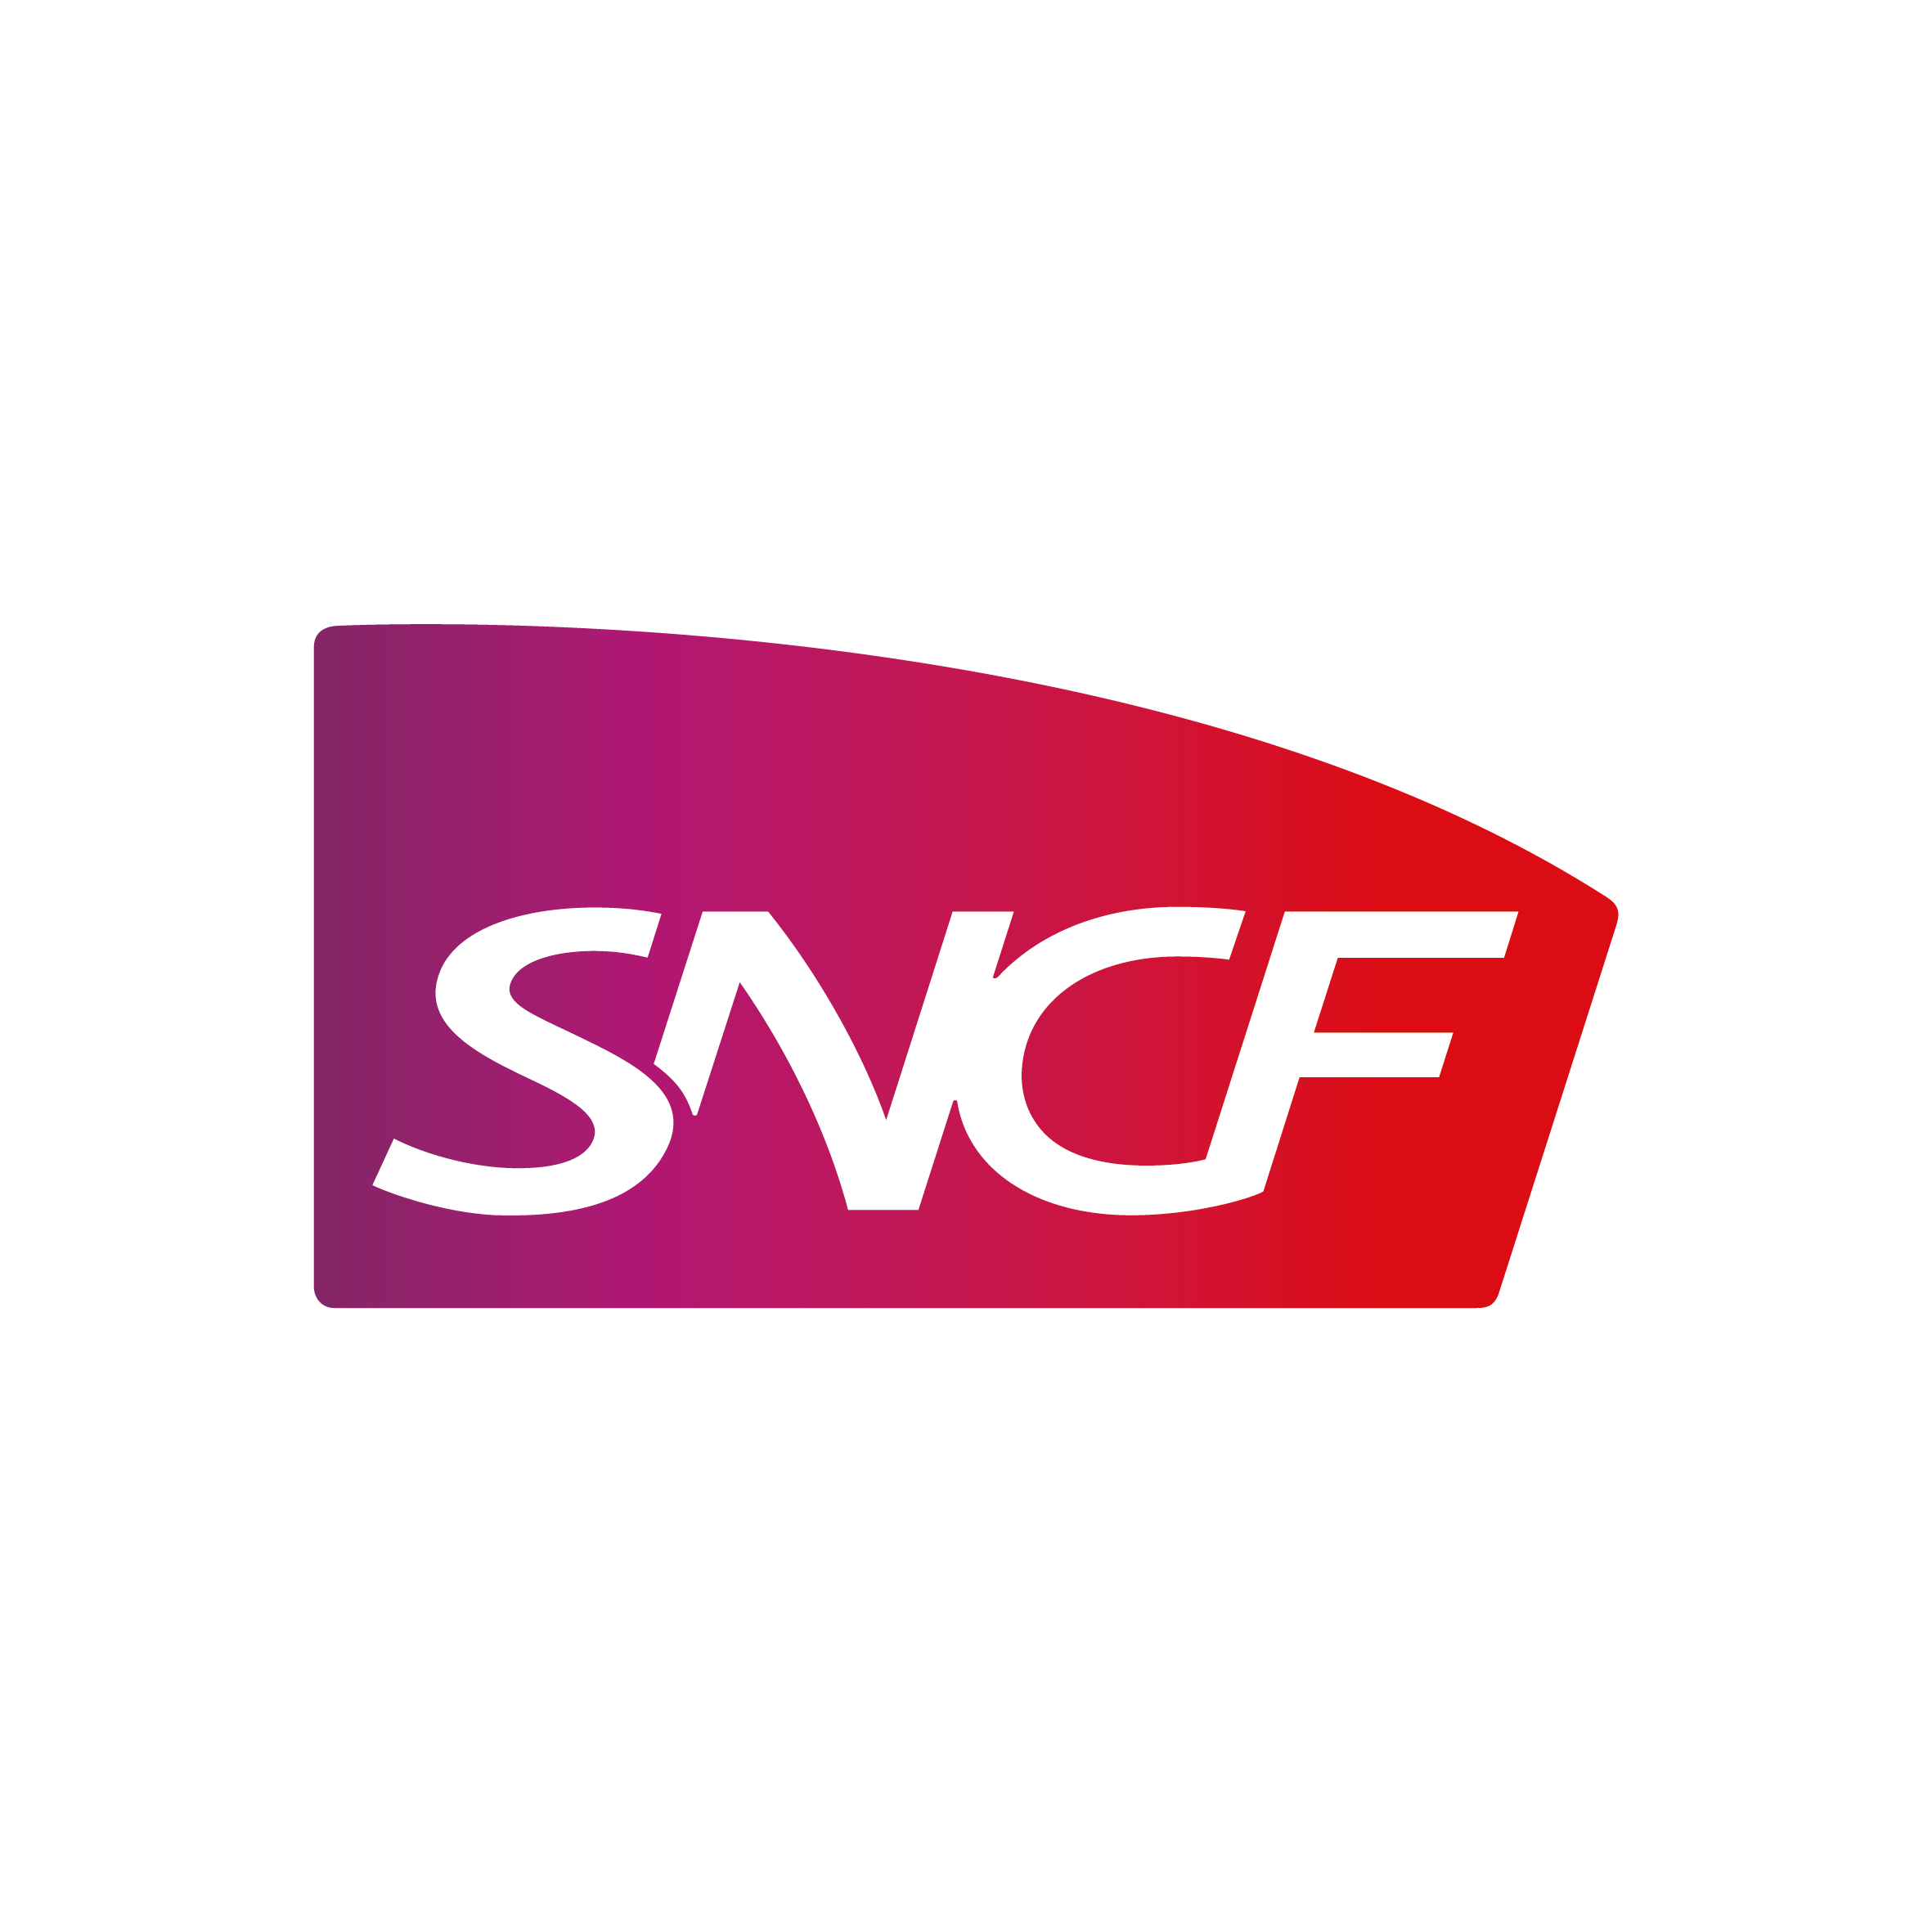SNCF | Société Générale
Tokheim Service Group

Independence
In order to avoid any situation of conflict of interest, companies offering services directly related to PostgreSQL (training, support, consulting, hosting, etc.) will not be able to join the group. They are nevertheless invited to make themselves known to be solicited.

Cooptation
In order to accept a new member into the Workgroup, a candidate must be accepted by at least half of the members subscribing to the PostgreSQLfr Association.

Privacy
Unless otherwise stated, all information exchanged within the group is confidential.
Each member of the Workgroup agrees not to disclose professional information to third parties presented within the group. The list of group members is not public.

Active participation
Each member has stated their intention to actively participate in the workgroup so that it is operational and actually make things happen.
This commitment is also divided into actions:
- be present at appointments
- give time to share & help
- to participate if possible financially:
  - by joining the association to help it in its role of promotion of PostgreSQL (membership of 400 € per year)
  - by “putting to the pot” to develop additional functions to PostgreSQL (exploitation, supervision, …)

If you are a candidate, you will also have to commit yourself to theses principles before being welcomed into the group.

Contact
The Workgroup is by nature “open” and enthusiastically welcomes good will.
- Contact : entreprises.contact@postgresql.fr
- Coordinator :
  - Simon CLAVIER (SNCF)
- Community Representative :
  - Laetitia AVROT
  - Damien CLOCHARD

Additional Info

Work in Progress
The Enterprise Workgroup organizes its work through specific projects, based on different subjects of interest. For each a project a volunteer is responsible for the animation.
There are currently 6 open projects :
- High availability
- Supervision
- Monitoring
- Usability
- Migration
- Promotion
Many other projects have been identified, they are waiting for the availability of a volunteer to be launched.

In the Press

About the Work Group
- CIO-Online (Fr) 06/12/2017 "Les entreprises exigent des éditeurs de progiciels le support de la base de données PostgreSQL"
- Le MagIT (Fr) 06/12/2017 "PostgreSQL : les entreprises françaises utilisatrices organisent leur résistance"
- Le MagIT (Fr) 18/11/2016 "La communauté française de PostgreSQL se structure pour les entreprises"

Related Topics
- JDN (Fr) 06/12/2017 "De grands projets open source lancés pour réduire la dépendance à Oracle"
- CIGREF (Fr) 03/07/2017 "Dégradation des relations entre les entreprises utilisatrices et Oracle"
  - le communiqué de presse en pdf
  - Le Monde Informatique 03/07/2017 "Le Cigref acte la rupture avec Oracle et pousse les alternatives"
  - CIO 03/07/2017 "Le Cigref va accompagner ses membres pour quitter Oracle"
- Campaign for Clear Licensing (En) 06/01/2015 "Open letter: To Larry Ellison and the board of directors at Oracle"

Join Us !


