T-Shirts & polos
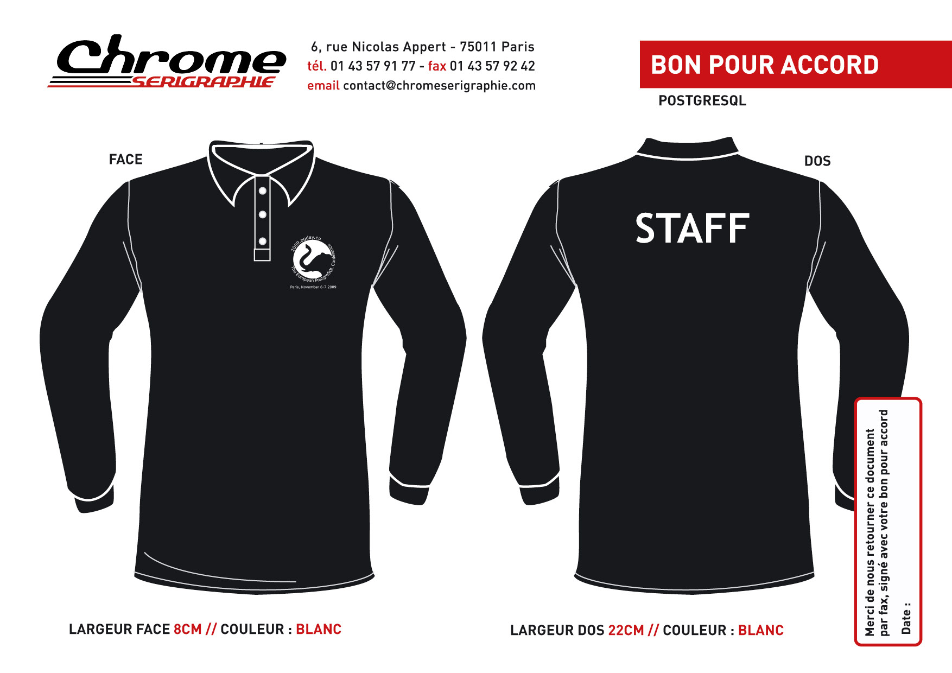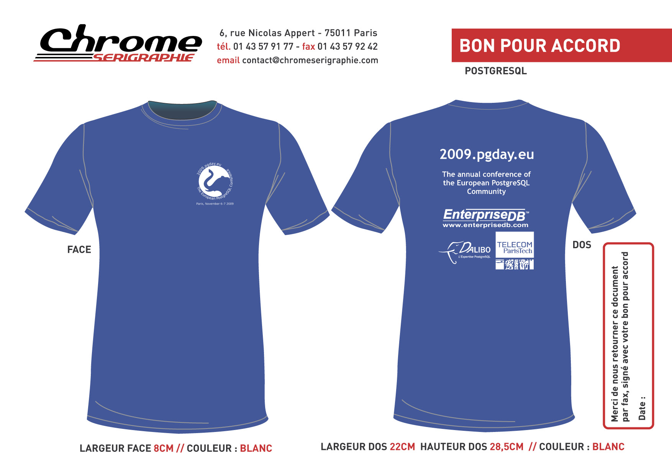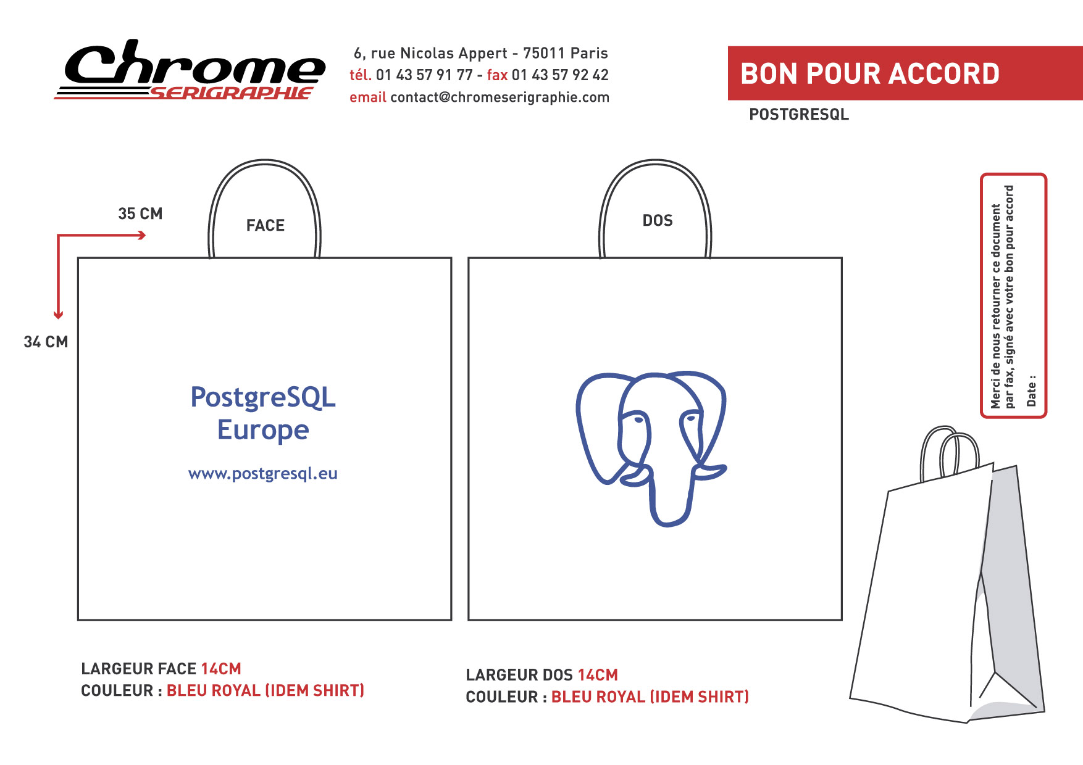
- 300 Blue-roi T-Shirts Men 180g / printed on both sides in white
- 15 black Polos Men 180g / printed on both sides in white
- 300 white plastic bags / printed on both sides blue-roi
Store | TShirts (noVAT) | Polos (noVAT) | Bags (noVAT) | Total Price (VAT incl.) | Comment
teeshirtplace | 1571.7€ | 144.37€ | 1200.6€ | 3775.38 € | bags are tote
Chrome Sérigraphie | 1515€ | 345 € | 780€ | 3 568,57 € | polos have long sleeves, bags are in paper
Urbancut |  |  |  |  | waiting for answer
spreadshirt |  |  |  |  | not contacted yet

Bags
* http://www.madetic.com/madetic_emballages/liste.htm

